SISTER NIVEDITA MONTESSORY SCHOOL
CLASS- I
MATHS- SOLVE & PRACTICE.
PAGE NO- 5,6,& 7 FROM JUNIOR MATHEMATICS BOOK.
SCIENCE-
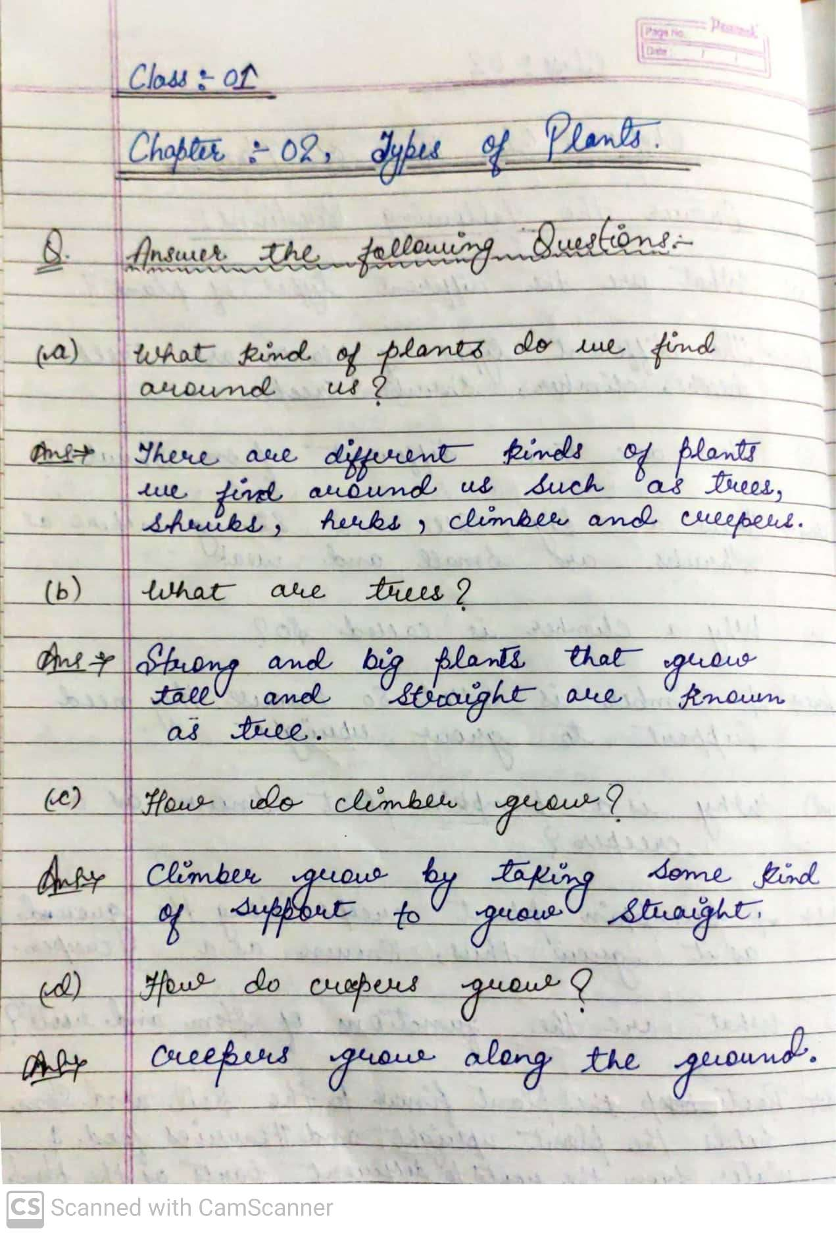

HINDI-
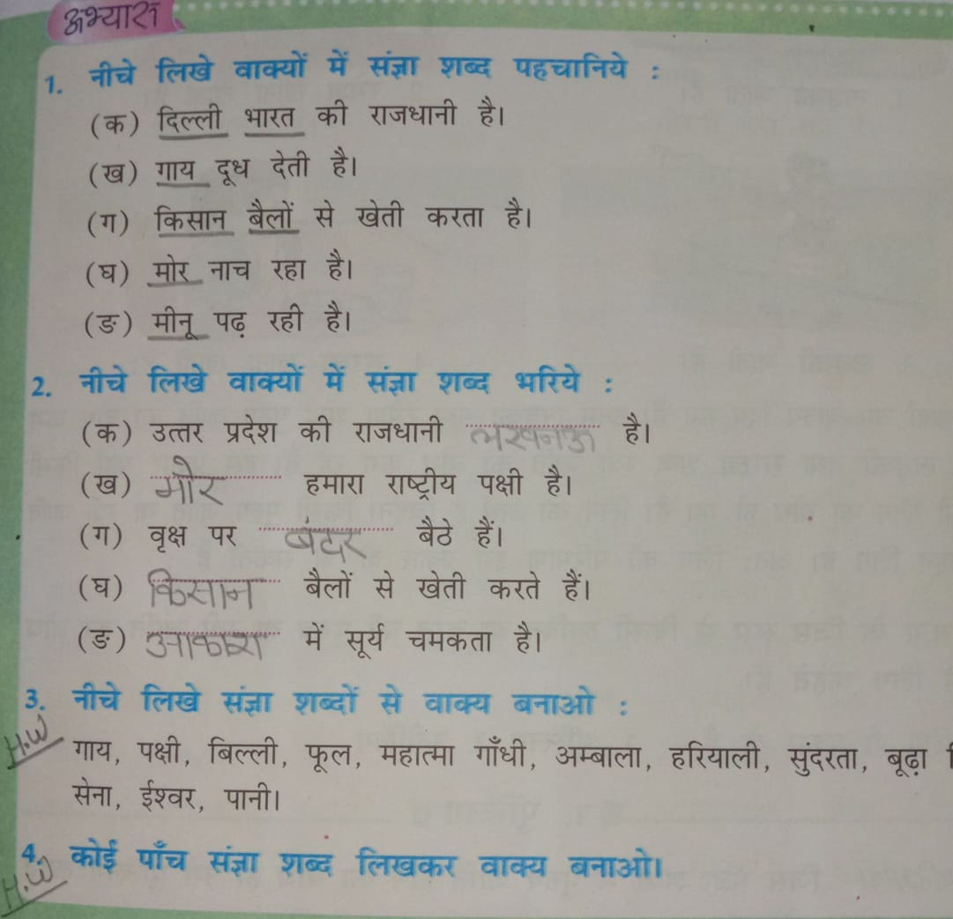

G.K-
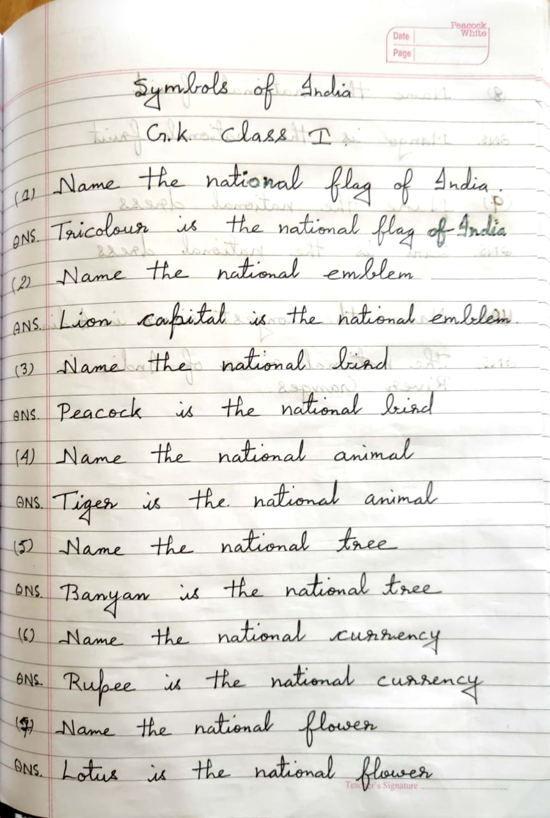
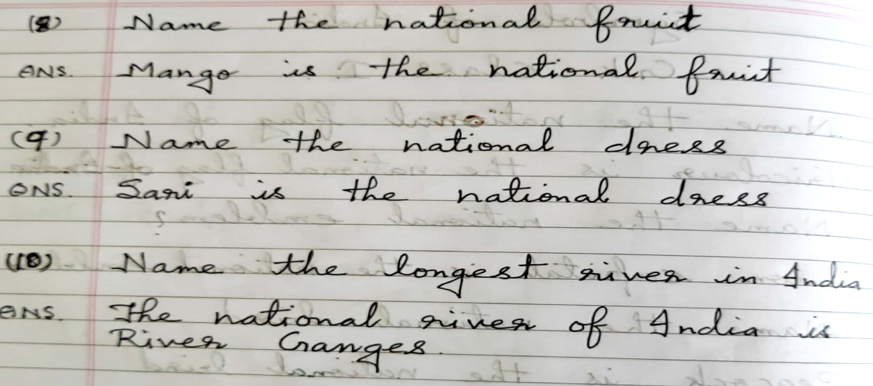

ENGLISH- 